# DATABASE AS A SERVICE (DAAS) BY CREATING AND CONFIGURING A NEW VM IMAGE

**STEP – 1:**

Create a new database.

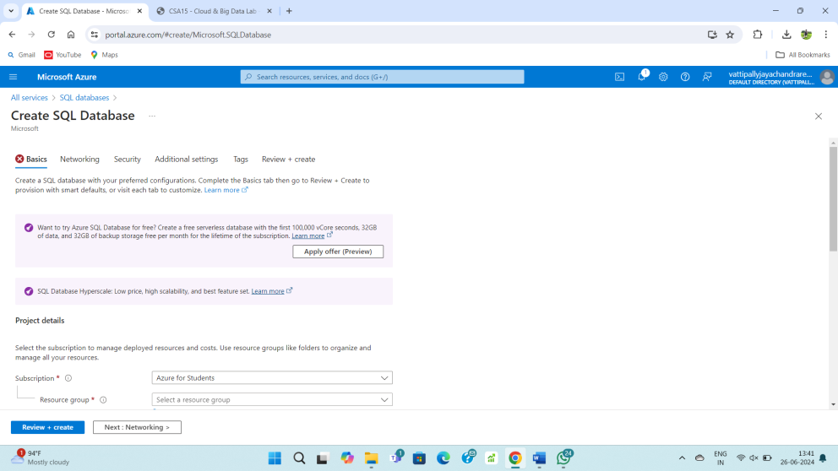

**STEP – 2:**

Fill upon the basics form.

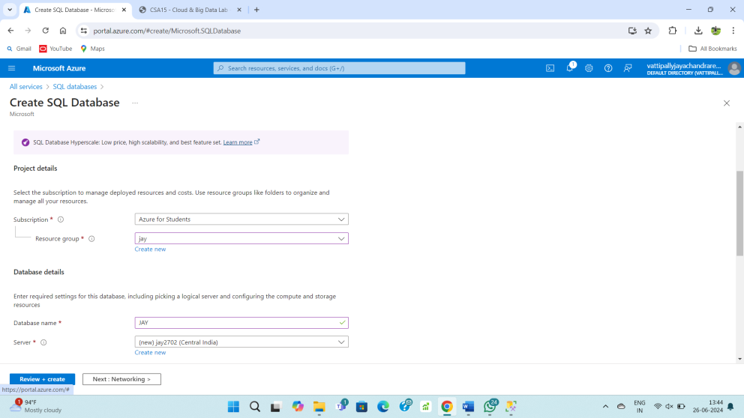

**STEP – 3:**

Fill upon the networking form.

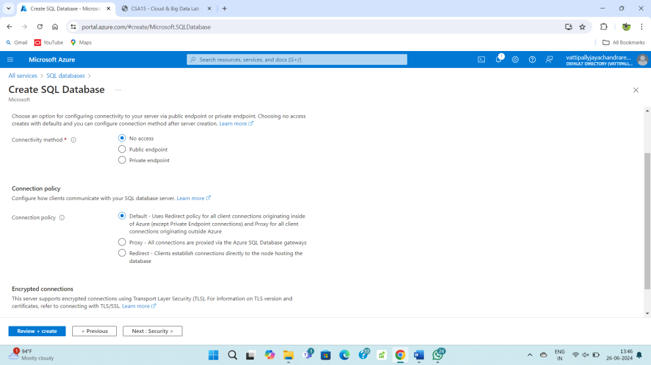

**STEP – 4:**

Fill upon the additional setting form.

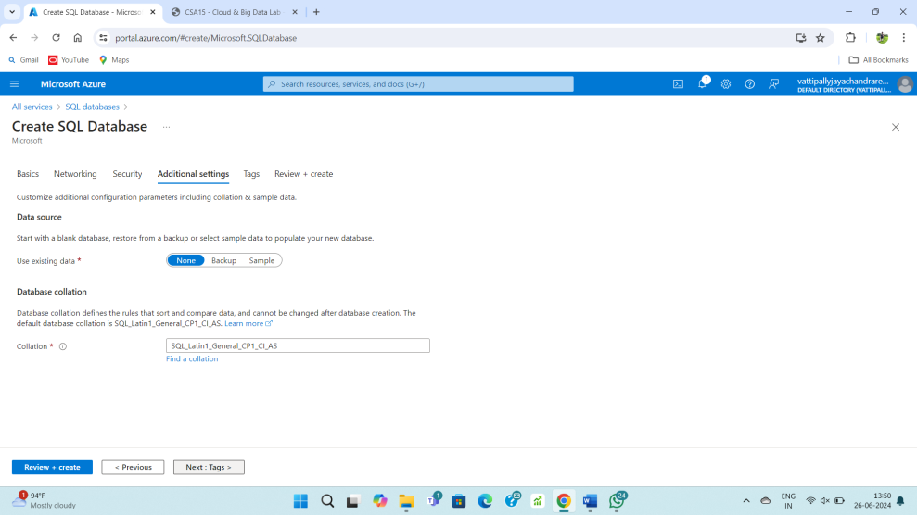

**STEP – 5:**

Fill upon the tags form.

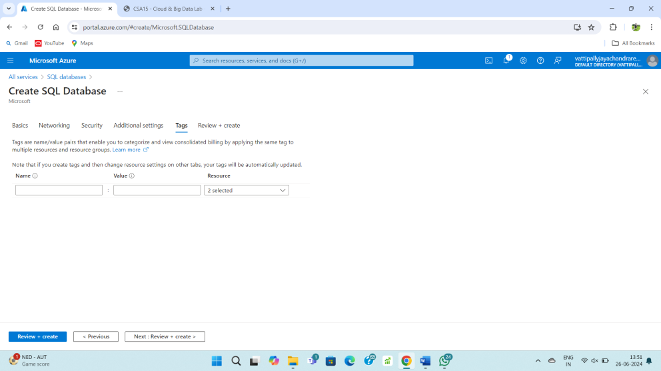

**STEP – 6:**

Review and create the database.

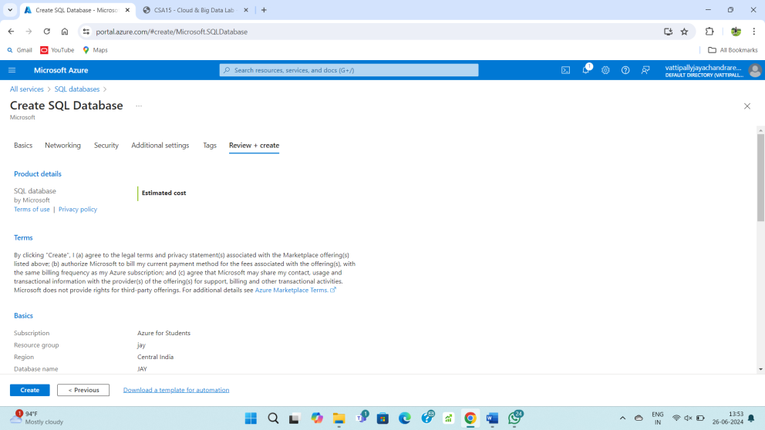

**STEP – 7:**

After deployment resource is ready to use.

